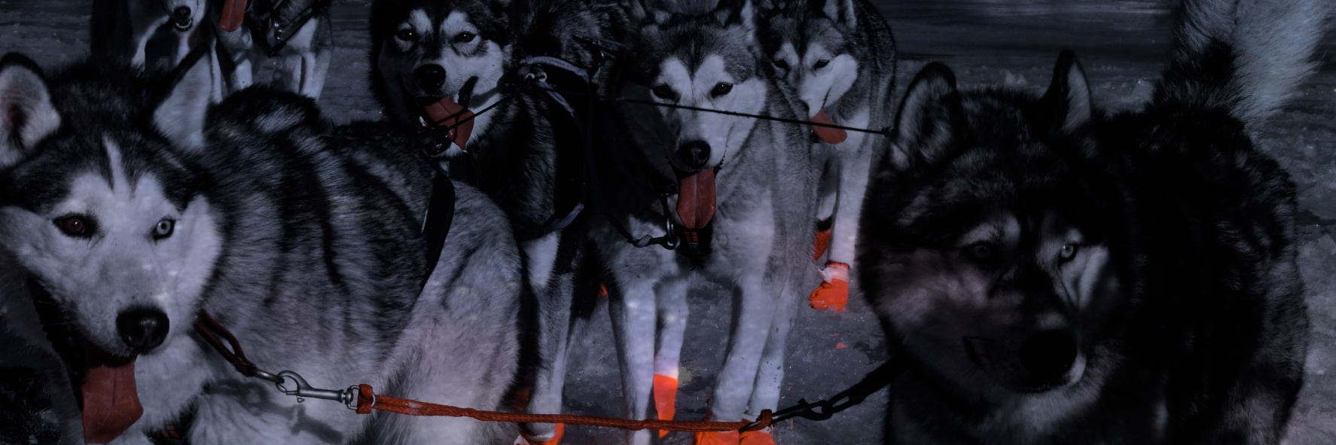
Silver Sled Race 2020 2 days…2 races…new trails
Schedule event

Saturday February 22nd

Sunday February 23rd

RACE 1 - SILVER SLED 100
STAGE 1: Haines Junction to Silver City, Arctic Institute.
START : Haines Junction
- 9.00 am : Convention Center area
- Registration
- Vet Check
- Volunteer’s meeting
- 9.30 am : Mandatory Musher’s meeting
- 11.00 am : Start time at the Rodeo grounds across Fas Gas.

In Silver City ( Arctic Institute )
- 5.30 pm : Musher ‘s dinner

Saturday February 22

RACE 1 - STAGE 2: Silver City, Arctic Institute to Artic Institute (new trail).
START: Silver City (Arctic Institute)
- Starting at 5.30 am: breakfast
- 7.30 am: Start time for Mushers.
Starting order will be in reverse order of arrival at Silver City (i.e. fastest team in Stage 1 will start last), minimum aggregate time will determine the winner.
Finish time is determined when the team and musher crosses the finish line.
Bibs must be worn over outerwear and be visible at all times.
*****

RACE 2- CHILLI PAW 40 – Haines Junction to Silver City
(Skijorers & recreational mushers are welcome)
- 8.45 am: Rodeo grounds across Fas Gas
- Registration
- Vet Check
- Volunteer’s meeting
- 9.00 am: Mandatory Musher’s meeting
- 10.00 am: Start time
Skijorers will start ½ hour (one half hour) before the first team departs
- 4 pm: Arctic Institute: Banquet for all participants

***************************
If you want to follow the mushers, you can find the map of the Silver Sled Race trail on facebook.
****************************
This is a community event! If you have a dog (pet and/or sled dog!), who does not behave well around other dogs, please leave the dog at home. We would like to avoid disturbances and keep it fun for everyone! At the arctic Institute, all dogs have to be tide up as we are beside an air strip. Thank you for your understanding!

